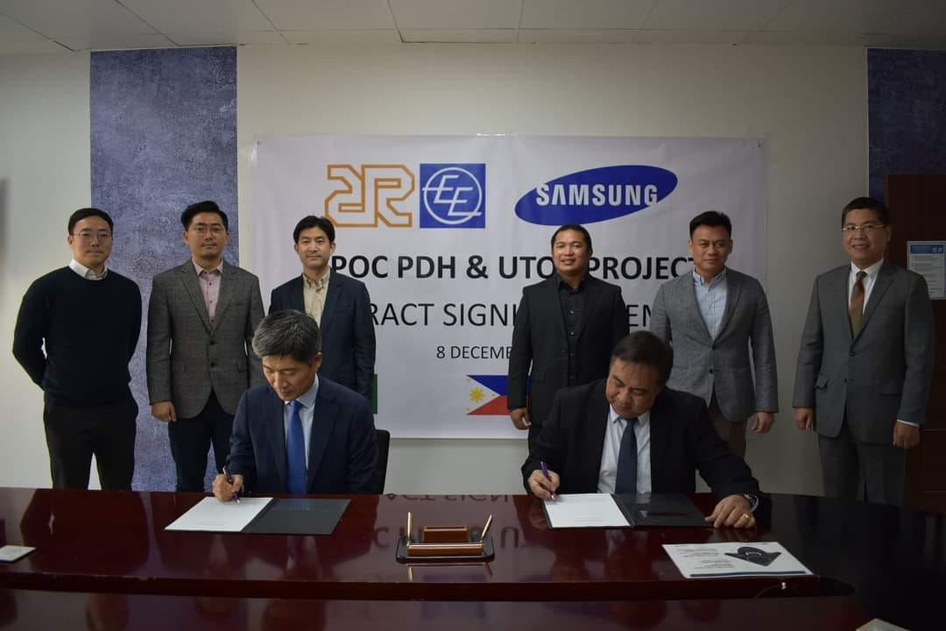

Al Rushaid Construction Company (ARCC) awarded $213.3m Propane Dehydrogenation Project

Al Rushaid Construction Co. Ltd. (ARCC), the joint venture firm between EEI Corporation, Philippines, and Al Rushaid Petroleum Investment Company (ARPIC), Saudi Arabia announced in a statement that it has secured a contract to build a Propane Dehydrogenation (PDH) Plant in Saudi Arabia.

The value of the contract is SAR 800 million (USD 213.3 million).

The PDH plant is located in Jubail 2 Industrial City, Eastern region of Saudi Arabia.

ARCC signed a contract for the construction of Advance Polyolefins Industry Company’s (APOC) PDH Plant, as well as its utilities and off-sites (UTOS) last month.

ARCC will carry out the civil, building, steel structure, mechanical, tank, piping, painting, electrical and instrumentation works of the project for a total of 25 months.

PDH Plant is a facility that produces propylene by removing hydrogen from propane while UTOS consists of water and air essential to plant utility production facilities that produce steam, auxiliary facilities, and water treatment facilities. APOC has contracted Lummus Technology of the US for licensing of its proprietary CATOFIN technology for the PDH Plant.

The PDH facility that will be producing propylene will have a nameplate capacity of 843,000 tons per year, feeding two Polypropylene (PP) Plants of 400,000 tons per year each for production of specialty polymers by manufacturers of face mask, automotive, pipes, food packaging, and textile industries.

Propane feedstock will be coming from Aramco under a long-term contract.

APOC is a joint venture of Advanced Global Investment Company (AGIC), a wholly-owned subsidiary of Advanced Petrochemical Company (APC) and SK Gas Petrochemical.

Work started this month and mechanical completion of the project by November 2023, the statement mentioned.